

We’re recruiting!

**17 Squadron is recruiting for 2021!**

Are you starting Yr 9 or 10 in 2021? Do you want to meet new friends, learn life skills through adventure training, and have a lot of fun?

If so, we want you to join the Air Training Corps!

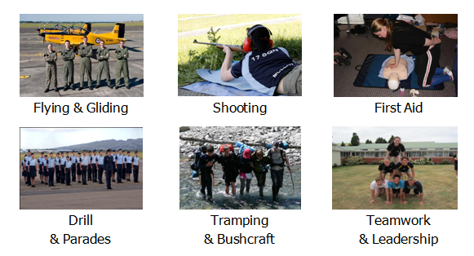

Interested? Come along to our next open evening!

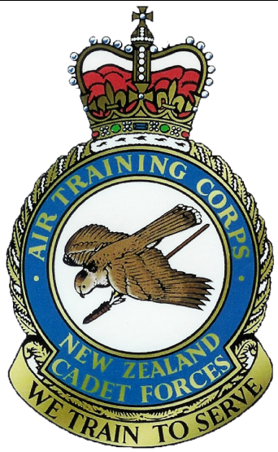

**Open Evenings**

Thursdays 6.30pm - 8.00pm

25th Feb; 4th, 11th, 18th Mar 2021

43 Corsair Drive, Wigram

Please wear school uniform.

Bring your friends!   
Parents are welcome.

**www.17squadronatc.com**



We’re recruiting!

**17 Squadron is recruiting for 2021!**

Are you starting Yr 9 or 10 in 2021? Do you want to meet new friends, learn life skills through adventure training, and have a lot of fun?

If so, we want you to join the Air Training Corps!



Interested? Come along to our next open evening!



**Open Evenings**

Thursdays 6.30pm - 8.00pm

25th Feb; 4th, 11th, 18th Mar 2021

43 Corsair Drive, Wigram

Please wear school uniform.

Bring your friends!   
Parents are welcome.

**www.17squadronatc.com**



We’re recruiting!

**17 Squadron is recruiting for 2021!**

Are you starting Yr 9 or 10 in 2021? Do you want to meet new friends, learn life skills through adventure training, and have a lot of fun?

If so, we want you to join the Air Training Corps!



Interested? Come along to our next open evening!



**Open Evenings**

Thursdays 6.30pm - 8.00pm

25th Feb; 4th, 11th, 18th Mar 2021

43 Corsair Drive, Wigram

Please wear school uniform.

Bring your friends!   
Parents are welcome.

**www.17squadronatc.com**

Any Questions?

*Check out www.17squadronatc.com   
or email recruiting@17squadronatc.com*

Can’t do Thursday evenings? Don’t panic!

There are other NZCF units in Christchurch.

**18 (Avon) Squadron, ATC**

<http://18sqn.cadetforces.org.nz/>

Parade on Tuesday evenings

**38 (Wigram) Squadron, ATC**

www.cadetforces.com

Parade on Wednesday evenings

**City of Christchurch Cadet Unit**

www.facebook.com/christchurch.cadets

Parade on Monday evenings

**Training Ship Godley, Sea Cadet Corps**

http://tsgodley.cadetforces.org.nz/

Parade on Tuesday evenings

**88 (Rangiora) Squadron, ATC**

<https://www.facebook.com/88SQN>

Parade on Thursday evenings

For more information on the NZ Cadet Forces, and to find units in your area, see:

http://www.cadetforces.org.nz/ Any Questions?

*Check out www.17squadronatc.com   
or email recruiting@17squadronatc.com*

Can’t do Thursday evenings? Don’t panic!

There are other NZCF units in Christchurch.

**18 (Avon) Squadron, ATC**

<http://18sqn.cadetforces.org.nz/>

Parade on Tuesday evenings

**38 (Wigram) Squadron, ATC**

www.cadetforces.com

Parade on Wednesday evenings

**City of Christchurch Cadet Unit**

www.facebook.com/christchurch.cadets

Parade on Monday evenings

**Training Ship Godley, Sea Cadet Corps**

http://tsgodley.cadetforces.org.nz/

Parade on Tuesday evenings

**88 (Rangiora) Squadron, ATC**

<https://www.facebook.com/88SQN>

Parade on Thursday evenings

For more information on the NZ Cadet Forces, and to find units in your area, see:

http://www.cadetforces.org.nz/

Any Questions?

*Check out www.17squadronatc.com   
or email recruiting@17squadronatc.com*

Can’t do Thursday evenings? Don’t panic!

There are other NZCF units in Christchurch.

**18 (Avon) Squadron, ATC**

<http://18sqn.cadetforces.org.nz/>

Parade on Tuesday evenings

**38 (Wigram) Squadron, ATC**

www.cadetforces.com

Parade on Wednesday evenings

**City of Christchurch Cadet Unit**

www.facebook.com/christchurch.cadets

Parade on Monday evenings

**Training Ship Godley, Sea Cadet Corps**

http://tsgodley.cadetforces.org.nz/

Parade on Tuesday evenings

**88 (Rangiora) Squadron, ATC**

<https://www.facebook.com/88SQN>

Parade on Thursday evenings

For more information on the NZ Cadet Forces, and to find units in your area, see:

http://www.cadetforces.org.nz/